***Wizard Screens***

1. *Employee Wizard screens*
2. *Personnel Details Screen*

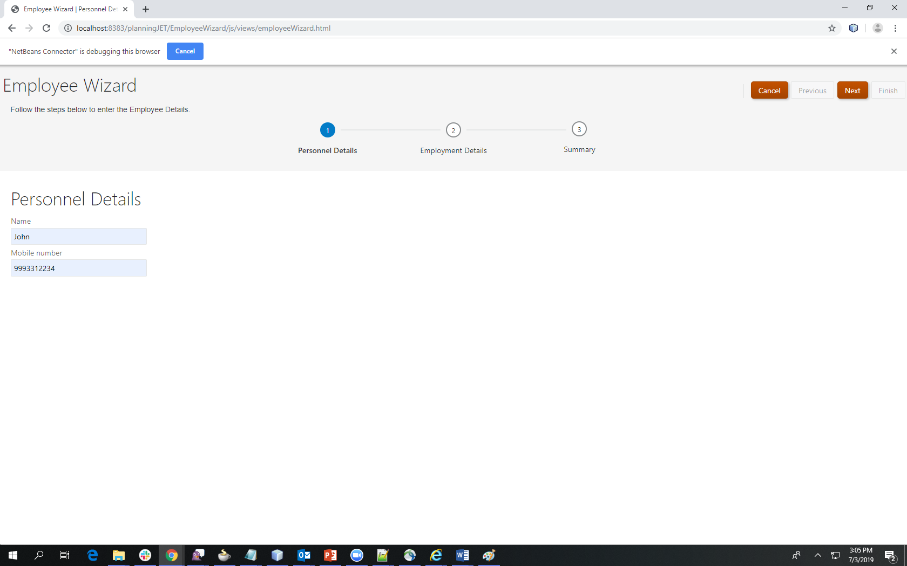

1. *Employment Details Screen*

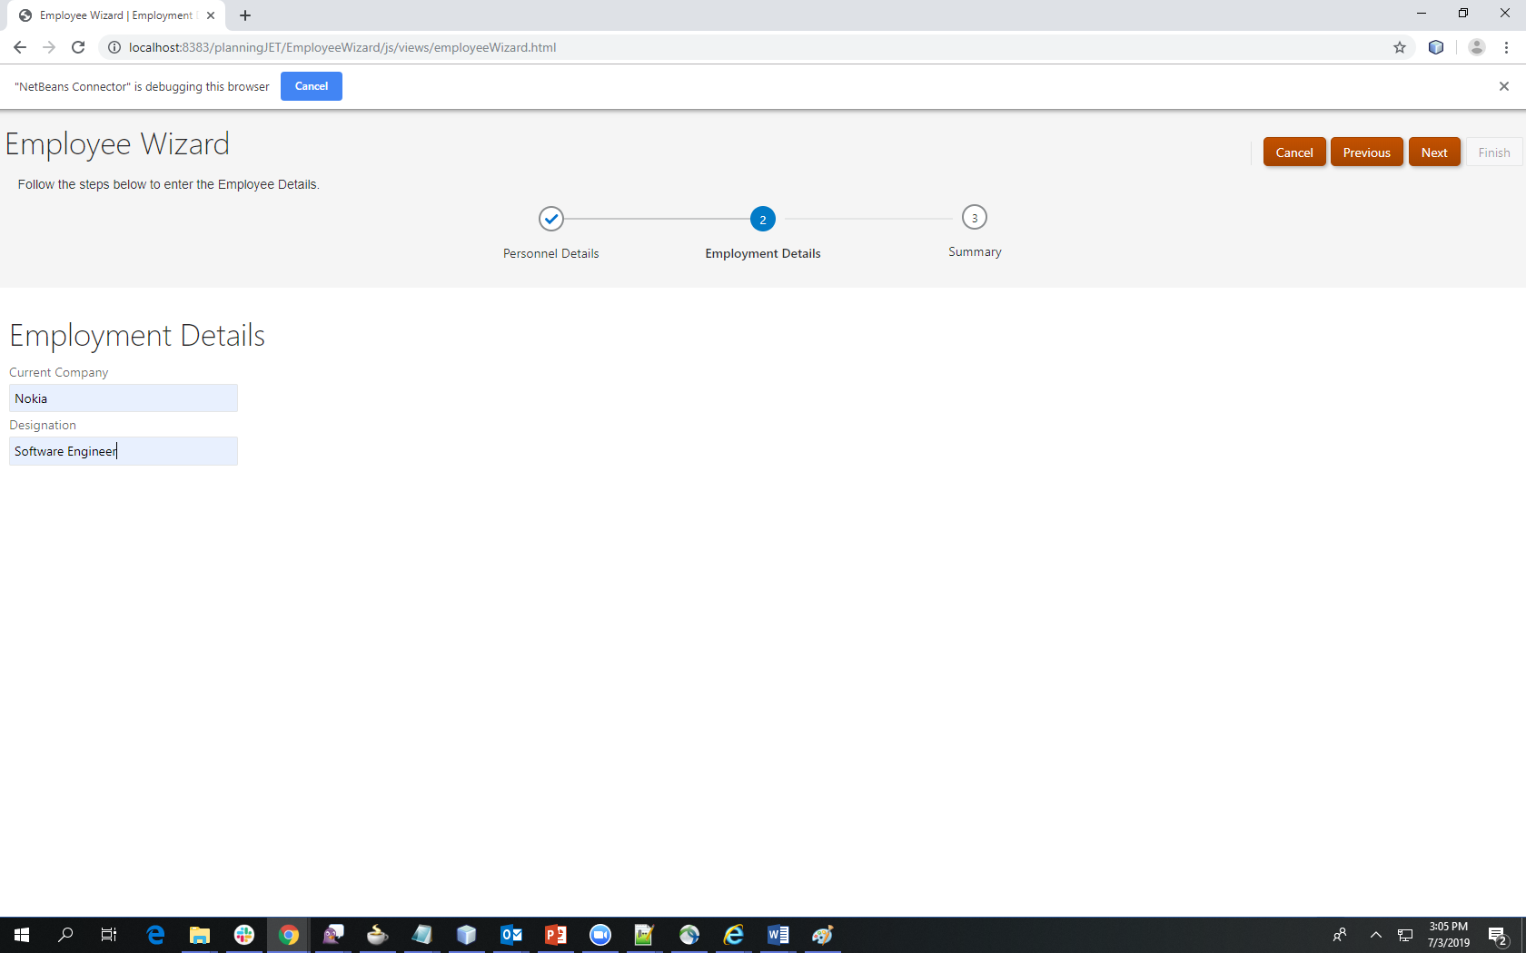

1. *Summary Screen*

